UNIVERSITY COLLEGE OF ENGINEERING AND TECHNOLOGY



PROJECT SYNOPSIS ON

BITCOIN PRICE PREDICTION

Submitted for the partial fulfillment for the degree of

Bachelor of Technology in

Computer Science and Engineering

Under the guidance of

**MR. NILABH KUMAR**

Submitted by

ANOOP SHUKLA 1709109

HARSH KUMAR 1709118

KHUSHBOO KUMARI 1709120

ROHIT HARSH 1709139

SHREYA 1709147

PROJECT GUIDE H.O.D CSE

**MR. NILABH KUMAR**  **MRS. GEETA SINHA**

(**Asst. Professor**)

***Certificate for Project***

This is to certify that this is a bonafide record of the project work done satisfactorily at “**UCET, VBU, HAZARIBAG”** by **The Project Associates,** in partial fulfilment of B. Tech Examination.

This report or similar report on the topic has not been submitted for any other examination and doesn’t form part of any other course undergone by the candidate.

ANOOP SHUKLA 1709109

HARSH KUMAR 1709118

KHUSHBOO KUMARI 1709120

ROHIT HARSH 1709139

SHREYA 1709147

Date: 15th May, 2021 **Prof. GEETA SINHA**

Place: HAZARIBAG (H.O.D. CSE)

UCET VBU HAZARIBAG

***Certificate***

This is to certify that the Project Report entitled **“BITCOIN PRICE PREDICTION”** done by **The Project Associates** is an authentic work carried out by them at **UCET VBU HAZARIBAG** under my guidance. The matter embodied in this project work has not been submitted earlier for the award of any degree to the best of my knowledge and belief.

ANOOP SHUKLA 1709109

HARSH KUMAR 1709118

KHUSHBOO KUMARI 1709120

ROHIT HARSH 1709139

SHREYA 1709147

Date: 15th May, 2021 **Prof. NILABH KUMAR**

Place: HAZARIBAG UCET VBU HAZARIBAG

JHARKHAND

ACKNOWLEDGEMENT

The satisfaction and euphoria that accompany the successful completion of any task would be incomplete without the mention of the people who made it possible, whose constant guidance and encouragement aided us in the completion of our project.

We consider it our privilege to express voice of gratitude and respect to all those who guided us and inspired us in the completion of this project.

We would like to express our thanks to **Prof. Nilabh Kumar** (CSE Dept, UCET, VBU) for his precious supervision and sheer motivation which happens to be the psyche of this project.

I would also like to express my heartfelt gratitude to **Prof. Geeta Sinha** (HOD CSE Dept., UCET, VBU) for her continuous encouragement and valuable guidance throughout our B. Tech journey.

And of course, nothing could have come true without the support of my family and friends for their constant encouragement and external support.

INDEX

|  |  |
| --- | --- |
| **S.NO.** | **TOPIC** |
| **1.** | **INTRODUCTION** |
| **2.** | **AIM** |
| **3.** | **REQUIREMENTS** |
| **4.** | **SYSTEM DESIGN** |
| **5.** | **SCOPE** |
| **6.** | **CONCLUSION** |

INTRODUCTION

A cryptocurrency is a form of digital asset based on a network that is distributed across a large number of computers. Bitcoin is the first and the most popular cryptocurrency introduced to humankind. It is a peer-to-peer digital cash system. And it helps send and receive money over the internet securely and at a fraction of cost compared to the traditional banking channel.

The **Bitcoin Price Prediction** system will help predict the value of Bitcoin currency for various period of the future. Based on the predictions made by the system one can predict on investing in Bitcoin in the near or long-term future.

A Bitcoin is simply like a computer file stored in a 'digital wallet' app on a smartphone or computer. You can send Bitcoins (or part of one) to a digital wallet. Every single transaction is recorded in a public list called the blockchain. That makes it possible to trace the history of Bitcoins to stop people from spending coins they do not own, making copies or undoing transactions.

This in-trend system is built using the concepts and algorithms of Deep Learning, which is a subset of Machine Learning. It involves training and testing the dataset under different Neural Network algorithms to find the most accurate and precise prediction.

This system will be helpful for investors and anyone who wishes to invest in bitcoins. Becoming a trend in the current scenario we have built a system to ease out the process by giving future predictions.

AIM

The main aim of this project is to forecast the Bitcoin price for various periods of future like next day, next week or next year based on the historical input data of the past. Based on the data, it can be predicted whether it is profitable to invest in Bitcoin for the long term. Also, comparison is made between the algorithms based on their accuracy of prediction.

REQUIREMENTS

**Software Requirements:**

* Windows 10
* Jupyter

**Language Requirements:**

* Python for Machine Learning

**Algorithms:**

* Recurrent Neural Network (RNN)
* Long Short Term Memory Networks (LSTM)

**Libraries:**

* NumPy
* Pandas
* Matplotlib
* Sklearn

SYSTEM DESIGN

* The system comprises of acquiring the dataset of historical values of Bitcoin online and storing all data in a .csv file.
* The different libraries are installed in the system.
* The data is visualized using the libraries and is known as Data Visualization.
* After the data is visualized, corrections are made in case of any errors or missing values in data.
* The data is then split into training and testing sets. The model is built on the training data and the system learns by applying algorithms on this dataset. After the model is built, it is tested on the testing data.
* Once the training and testing is done on the dataset, we check for accuracy of our system and make further changes if necessary.
* For better understanding of the concept a similar format of the system is shown in the following images:

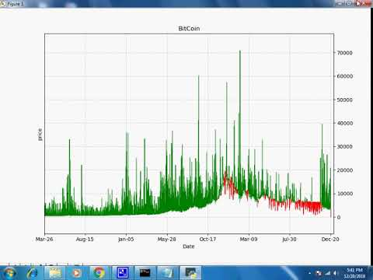

FLOWCHART

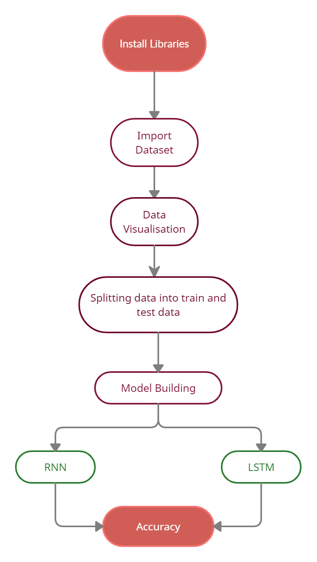

SCOPE

In the proposed Bitcoin Price Prediction system, there is a scope of improvement of the system. The system can still produce more accuracy in the prediction by performing more complex algorithms and repetition. Apart from prediction many more features can be added and other crypto currencies can also be added. The system can also be integrated with a user interface for user friendly experience.

The people who are not much aware of crypto currencies can also then come to know and invest in them in the upcoming future.

CONCLUSION

Even though a few years have passed of Bitcoin being created, it is still known to very few people. Even after knowing about it, people refrain from investing in it due to the fear of losing money.

This Bitcoin Price Prediction system will help predict the price of Bitcoin in the near future based on the previous historical data as input. This will help people in investing in it with a security in mind and less fear.

There is a high scope of the value to increase in the coming years and with everything getting online, there is a need to stay updated with the trending technologies and currency.

The model will be built using Machine Learning algorithms and will provide an insight into the future value.